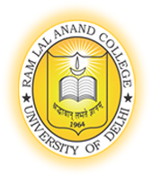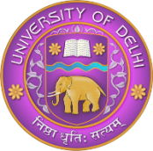
RAM LAL ANAND COLLEGE (University of Delhi)
Faculty Details
Title | Dr. | First Name |  | Reena | Last Name | Kasana | Photograph
Designation |  | Assistant Professor
Address |  | Department of Hindi, Ram Lal Anand College, University of Delhi- 110021
Phone No Office |  | 011-24112557
Residence
Mobile
Email |  | Reena.hindi@rla.du.ac.in
Web-Page
Educational Qualifications
Degree |  |  | Institution |  |  |  | Year
PhD |  |  | Department of Hindi, University of Delhi |  |  |  | 2022
MPhil |  |  | Department of Hindi, University of Delhi |  |  |  | 2017
MA |  |  | Miranda House, University of Delhi |  |  |  | 2014
B.ed |  |  | Central Institute of Education, University of Delhi |  |  |  | 2015
B.A |  |  | Miranda House, University of Delhi |  |  |  | 2012
Career Profile
UGC NET/Junior Research Fellow in June 2015
Assistant Professor (Adhoc) in Department of Hindi, Bhagini Nivedita College, University of Delhi from 2018- 2023.

Assistant Professor in Department of Hindi, Ram Lal Anand College, University of Delhi from 3rd April 2023.

Administrative Assignments
Azaadi ka Amrit Mahotsav Committee, Magazine Committee, Admission Committee, Placement Cell and Welfare Committee, Health and Hygience Committee (Bhagini Nivedita College)

Member of ISO 21001:2018 Internal Audit Committee, Member of EOC, Member of Art and Culture Committee, Member of Ambedkar periyar Phule Study Circle

Areas of Interest / Specialization
रीतिकालीन हिंदी साहित्य,आधुनिक हिंदी कविता,भाषा विज्ञान

Subjects Taught
Hindi Bhasa aur Sahitya, Hindi Aupcharik Lekhan, Hindi Sahitya ka Itihaas (Aadikaal aur Madhya kaal), Hindi Upanyas, Hindi Kavita (Riti kalin Kavya), Hindi Bhasa ka vyavharik Vyakaran, Hindi Cinema aur uska adhyan, Hindi Gadya udbhav aur vikas,
Research Guidance
Publications Profile (Books/Chapters/Research articles, etc.) (Last 10 publications)
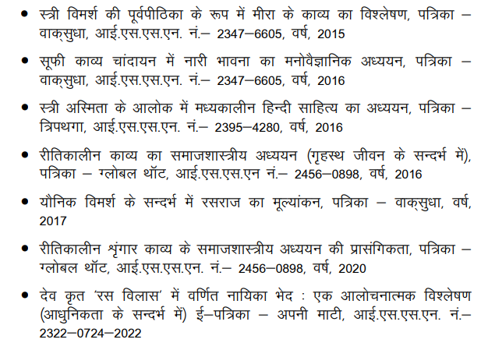
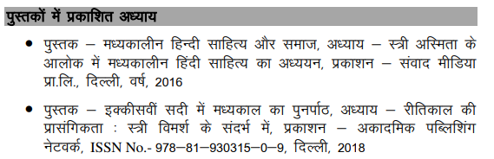

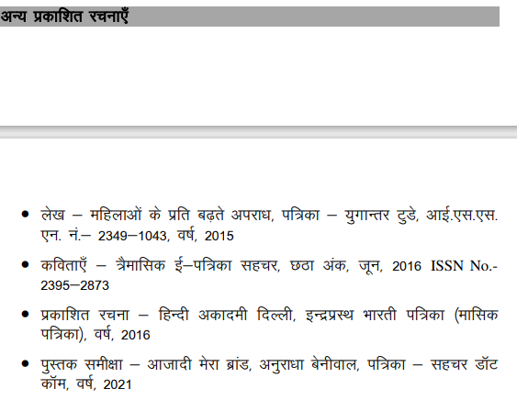
- शोध आलेख- नई राष्ट्रीय शिक्षा नीति (2020) के परिप्रेक्ष्य में भारतीय भाषाओं का प्रश्न,पत्रिका- आधुनिक साहित्य,(साहित्य,संस्कृति और आधुनिक सोच की त्रैमासिक), यूजीसी केअर लिस्टेड अप्रैल-जून,2023

Conference Organization/ Presentations (in the last three years)
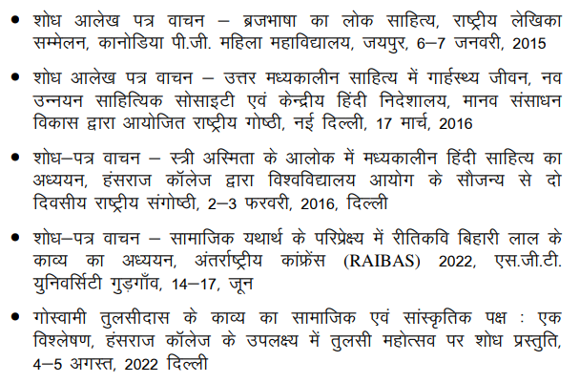
- शोध पत्र वाचन- विषय-'नई राष्ट्रीय शिक्षा नीति 2020 के परिप्रेक्ष्य में भारतीय भाषाओं का प्रश्न' अंतरराष्ट्रीय संगोष्ठी,नई दिल्ली -इंडिया इंटरनेशनल सेंटर,21-22,जनवरी,2023
- शोध पत्र वाचन- विषय- 'दीनदयाल और उनका एकात्म दर्शन:एक अध्ययन' राष्ट्रीय संगोष्ठी, पी.जी.डी.ए.वी (सांध्य) एवं ' भारतीय भाषा समिति,शिक्षा मंत्रालय' नई दिल्ली,10-12, फरवरी, 2023

Research Projects (Major Grants/Research Collaboration)
Awards and Distinctions
Association With Professional Bodies
Other Activities
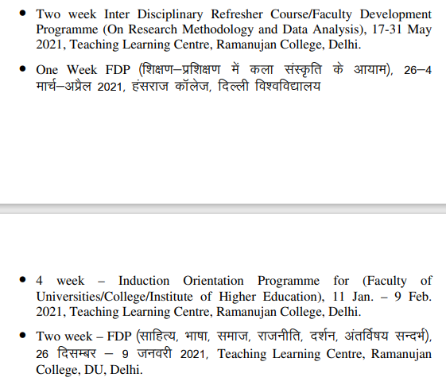
- NCC “C” Certificate Holder
- Four Week Faculty Induction Programme for “Faculty in Universities/ Colleges/ Institutes of Higher Education from 23 April- 22 May 2023 and Obtained Grade A+.
- Participated in workshop titled “Rajbhasa ka Kanuni aur Vyavharrik Paksh organized by Rajbhasa Kriyanvyan Samiti, Bhagini Nivedita College on 19th January 2023.

